Docker image build by Docker Compose and running container from that image on ubuntu
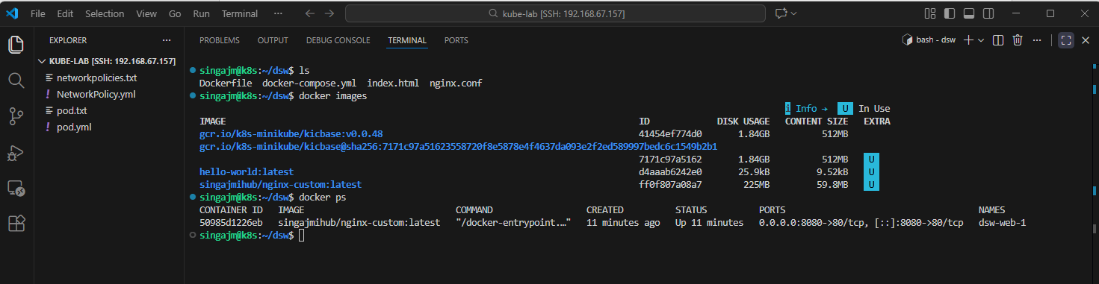
Docker image to the Docker HUB
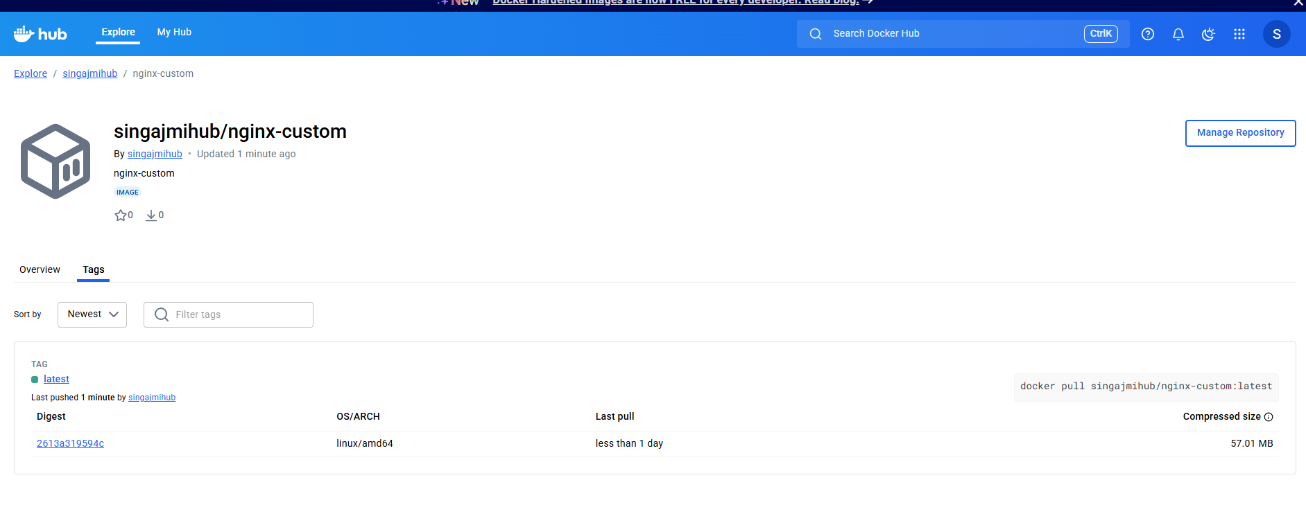
Nginx running image


Addition print-screen for Dockerfile, local directory html that hold the nginx main page index.html and mounted inside the container. This state demonstrate that the mounted volume is persistence even if the container is killed, the data remain safe.
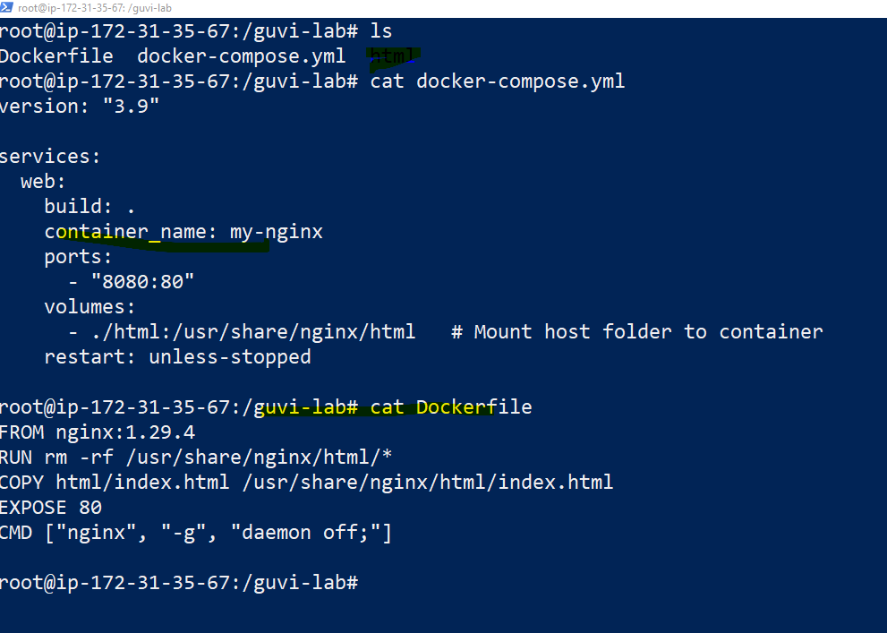

Killed the container and reload the page which is working fine

